名稱怎翻較好

Mailman Max

在這個專案中，你會建立一個中央郵件處理系統，這個系統會分類信件，將每封信放到正確的郵件車上。

In this project you will make a main postal sorting office. It will need to sort letters so that they can be put into vans going to the right local sorting offices.

區域縮寫是決定一封信接下來該去哪個郵政中心的重要資訊，你將會訓練電腦辨別不同的手寫區域縮寫，並利用這些資訊來分類信件。

The postcode is a great way to work out the next sorting office a letter should go to, so you’ll use that.

You’ll train the computer to recognise what the different codes at the start of a postcode look like when they are hand-written, and use that to sort letters.

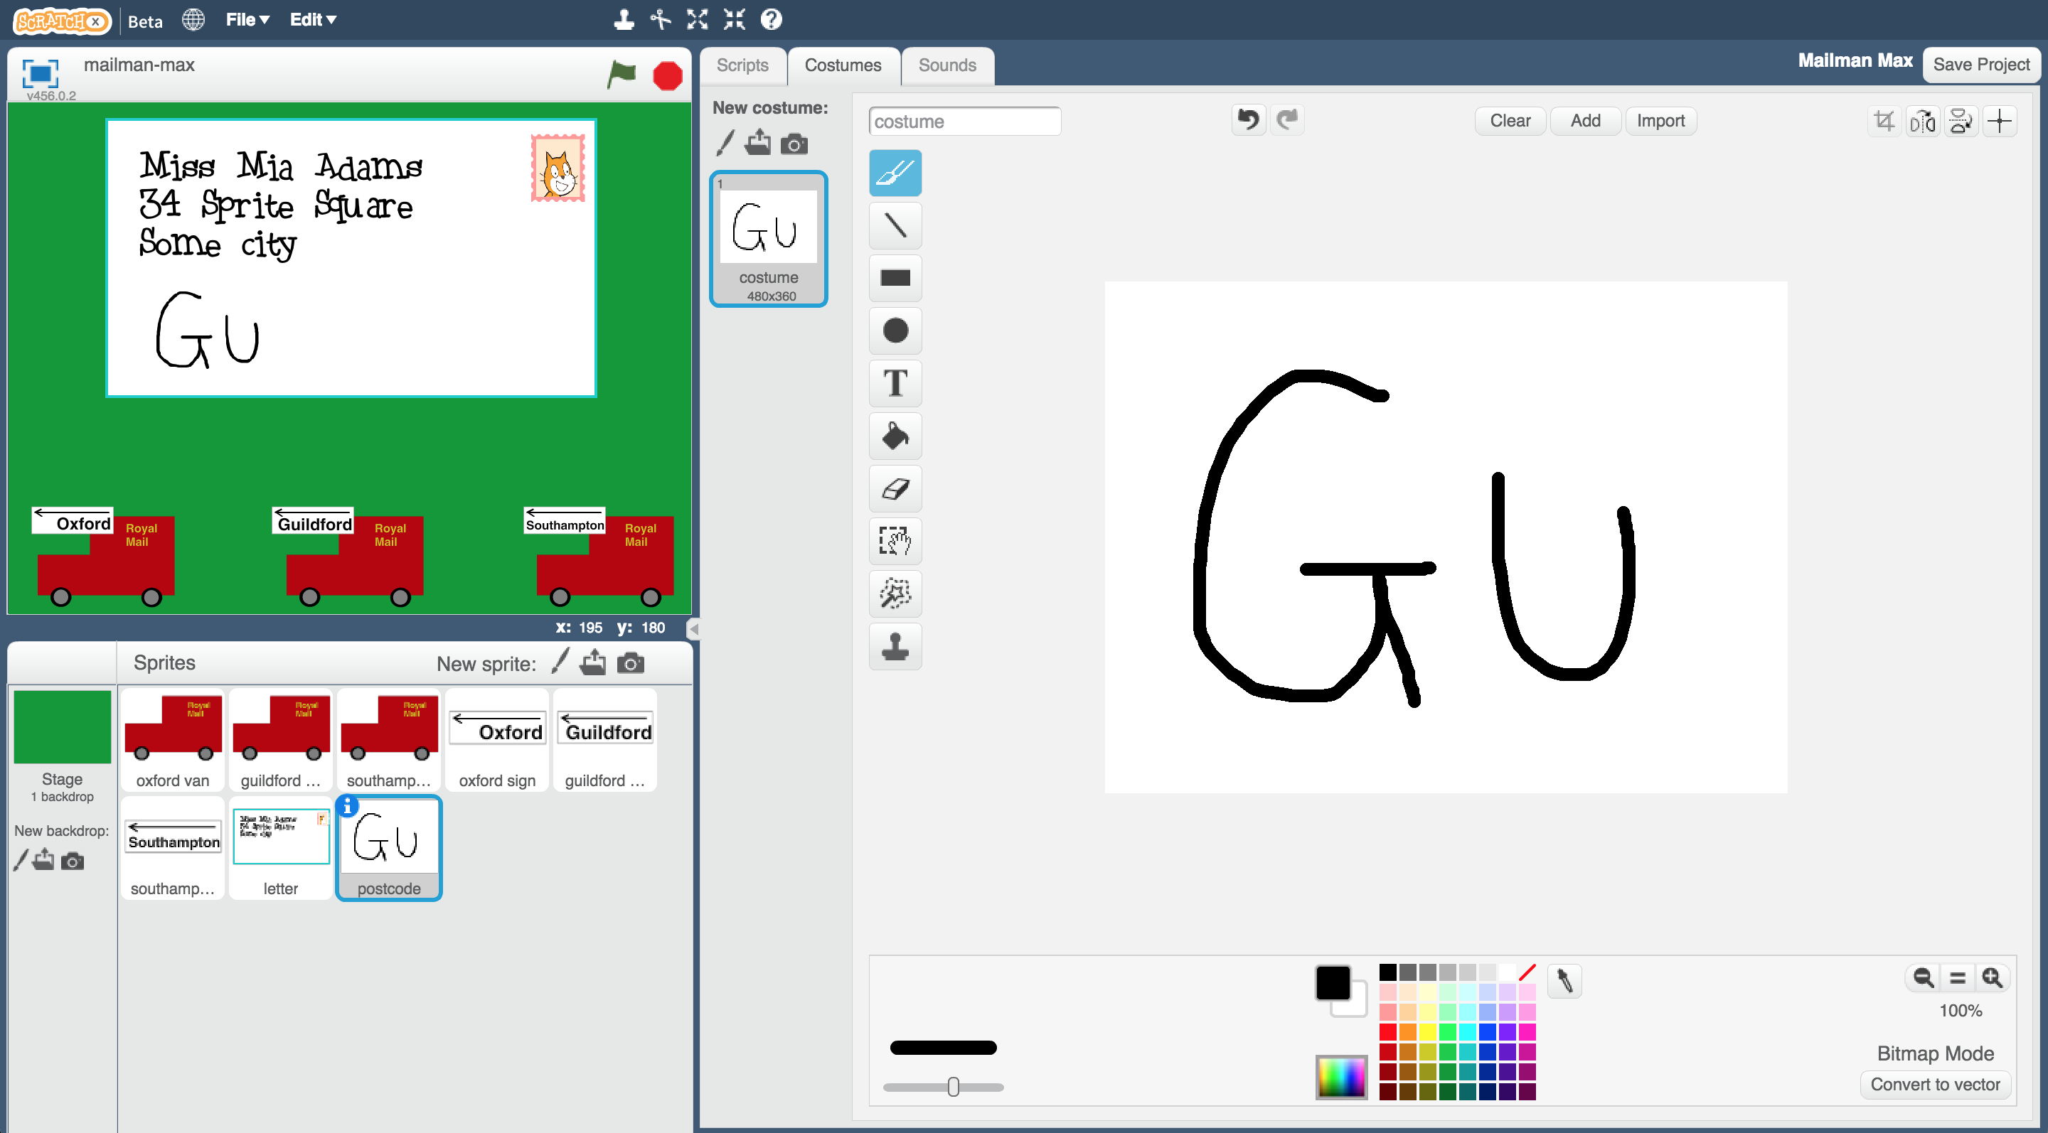

This project worksheet is licensed under a Creative Commons Attribution Non-Commercial Share-Alike License

http://creativecommons.org/licenses/by-nc-sa/4.0/

1. 搜尋網頁：[https://machinelearningforkids.co.uk](https://machinelearningforkids.co.uk/)

Go to [https://machinelearningforkids.co.uk](https://machinelearningforkids.co.uk/) in a web browser

1. 點選“**Get started**”按鈕

Click on “**Get started**”

1. 點選“**Log In**”按鈕並登入系統

*如果你沒有帳號，請你的老師幫你建立一個帳號。*

*如果你不記得你的帳號或密碼，請你的老師幫你重新設定一次。*

Click on “**Log In**” and type in your username and password  
*If you don’t have a username, ask your teacher or group leader to create one for you.  
If you can’t remember your password, ask your teacher or group leader to reset it for you.*

1. 點選上方清單中的 **”Projects”** 按鈕

Click on “**Projects**” on the top menu bar

1. 點選 “**+ Add a new project**” 按鈕

Click the **“+ Add a new project**” button.

1. 將你的專案命名為 “Mailman Max”並設定成辨識 “**images**”類別

Name your project “Mailman Max” and set it to learn how to recognise “**images**”.   
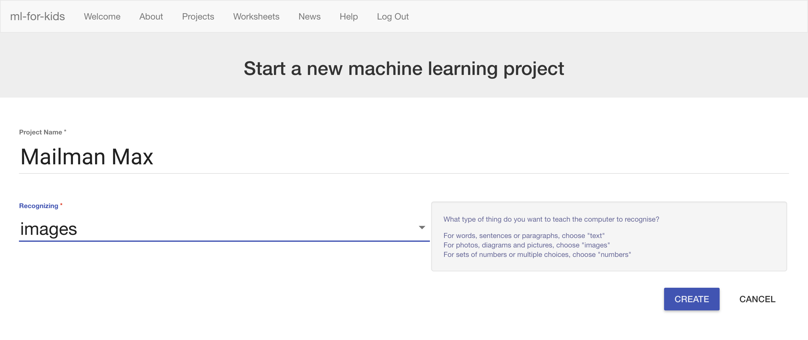

1. 點選 “**Create**”按鈕

Click the “**Create**” button

1. 你會在專案清單中看到“**Mailman Max**”，點選此專案

You should see “**Mailman Max**” in the list of your projects. Click it.

1. 點選 **”Train”** 按鈕

Click the “**Train**” button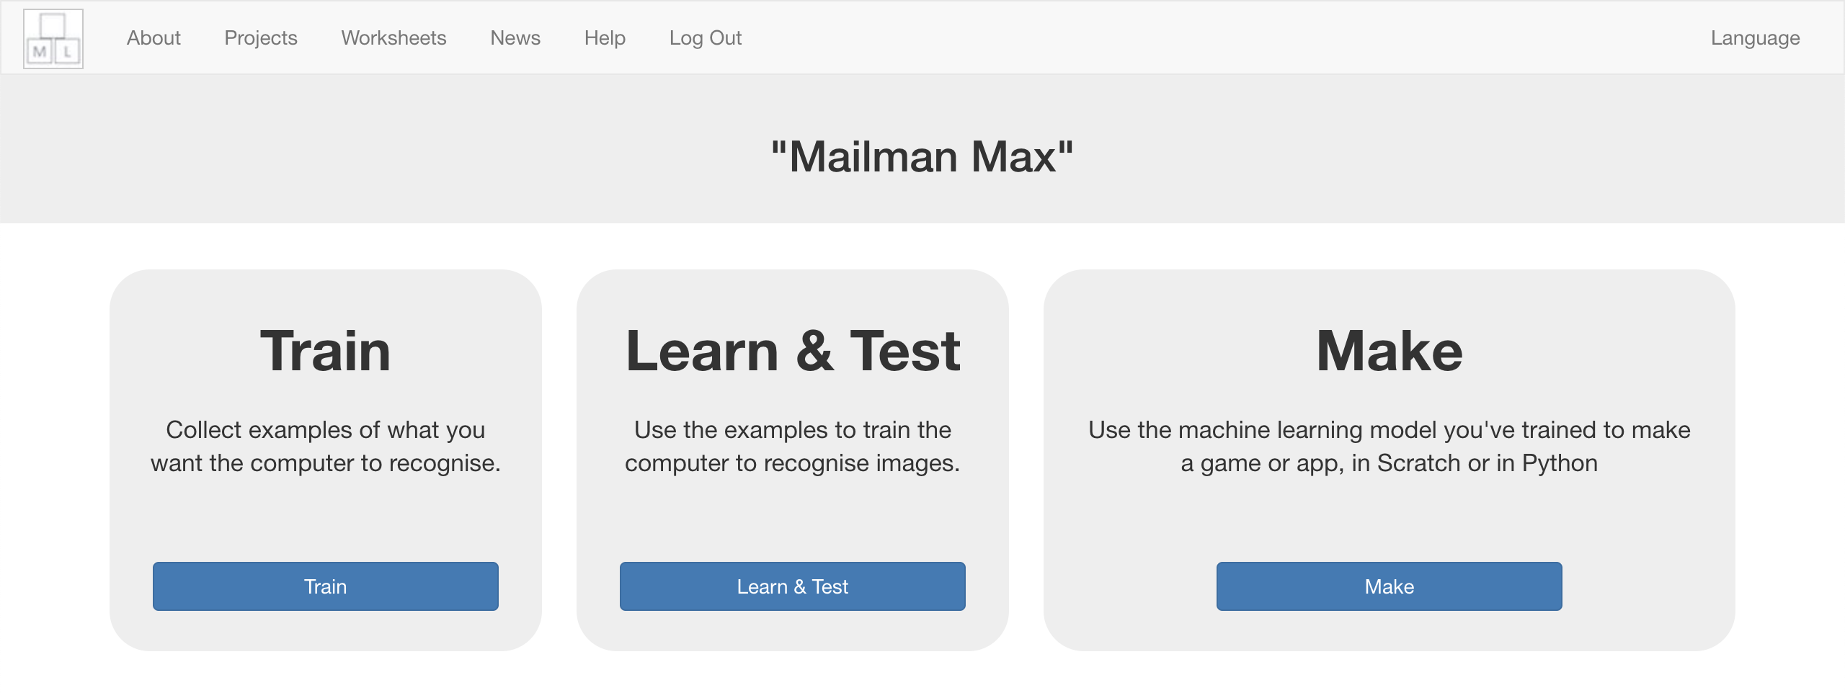

1. 點選 “**+ Add new label**”按鈕，建立一個叫”Oxford”的標籤

Click the “**Add new label**” button, and create a label called “Oxford”  
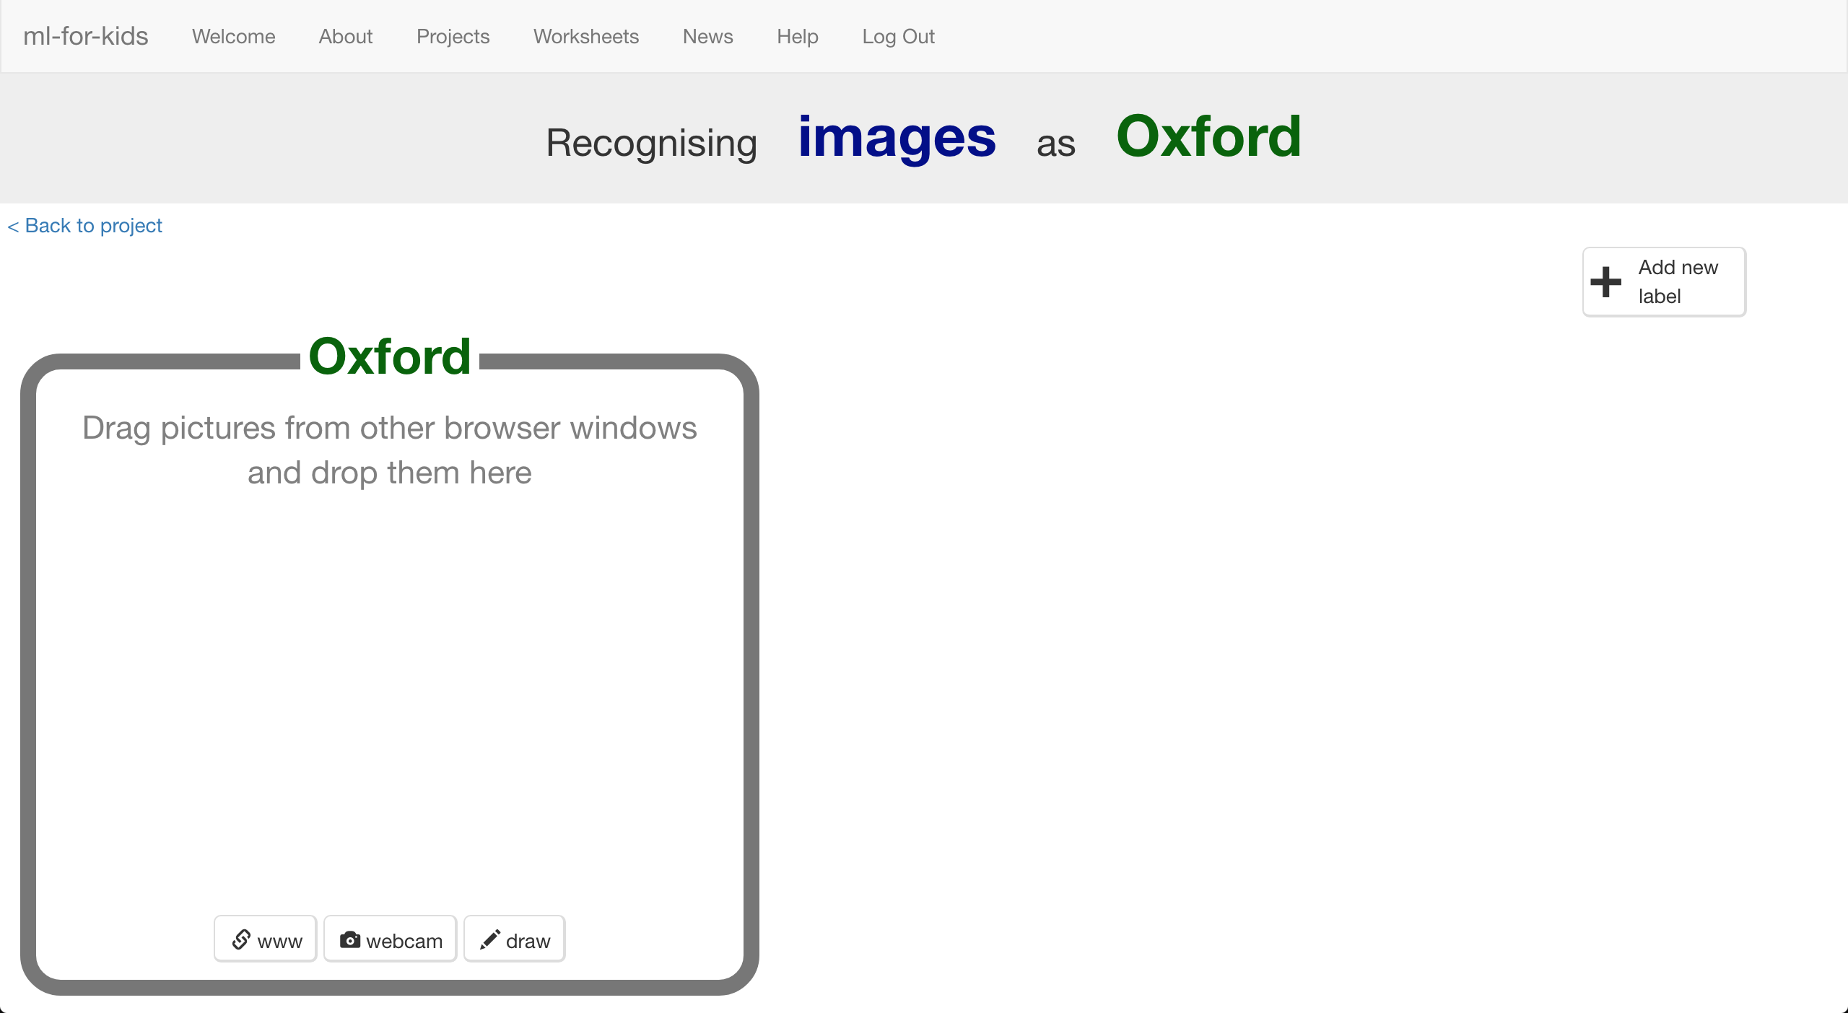

1. 點選”Oxford”方框中的“**draw**”按紐

Click the “**draw**” button in the “Oxford” bucket  
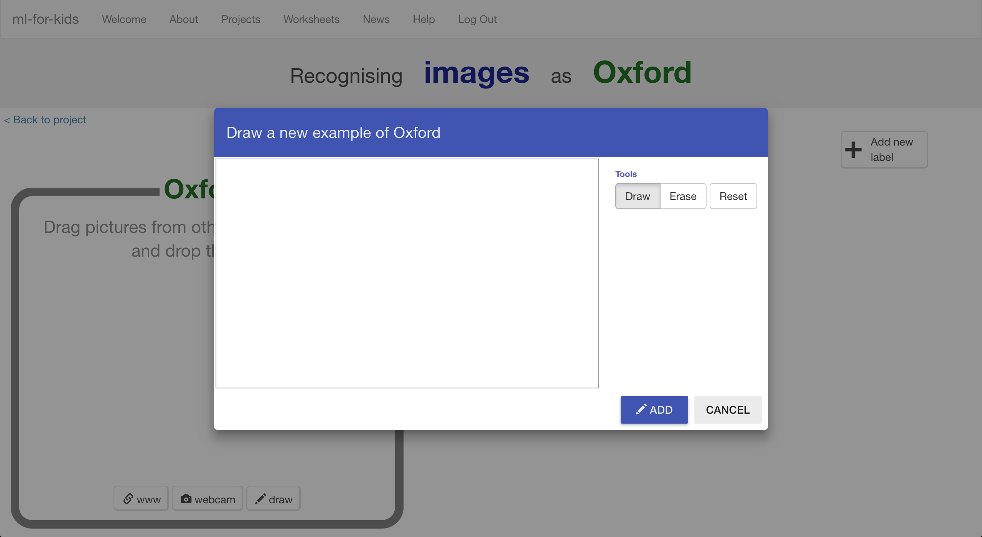

1. 使用滑鼠在空白框裡寫出”OX”

*Ox是Oxford區域的區域縮寫*

*盡可能寫大一點，如下圖*

Use your mouse to write “**OX**” in the empty box.   
*OX is the start for postcodes in the Oxford area.   
Try to use all the space in the box, like in the picture below.  
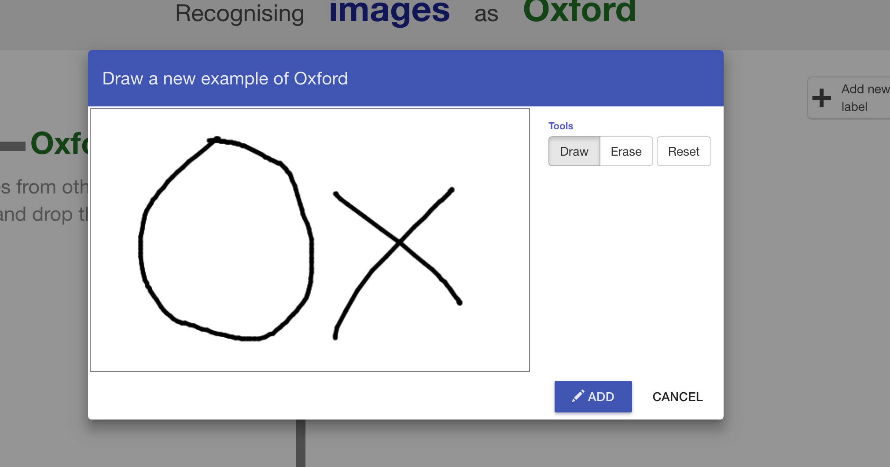*

1. 點選“**ADD**”

Click “**ADD**”

1. 再點選一次“**Draw**”並再寫一次“OX”

Click “**Draw**” again, and draw another “OX”  
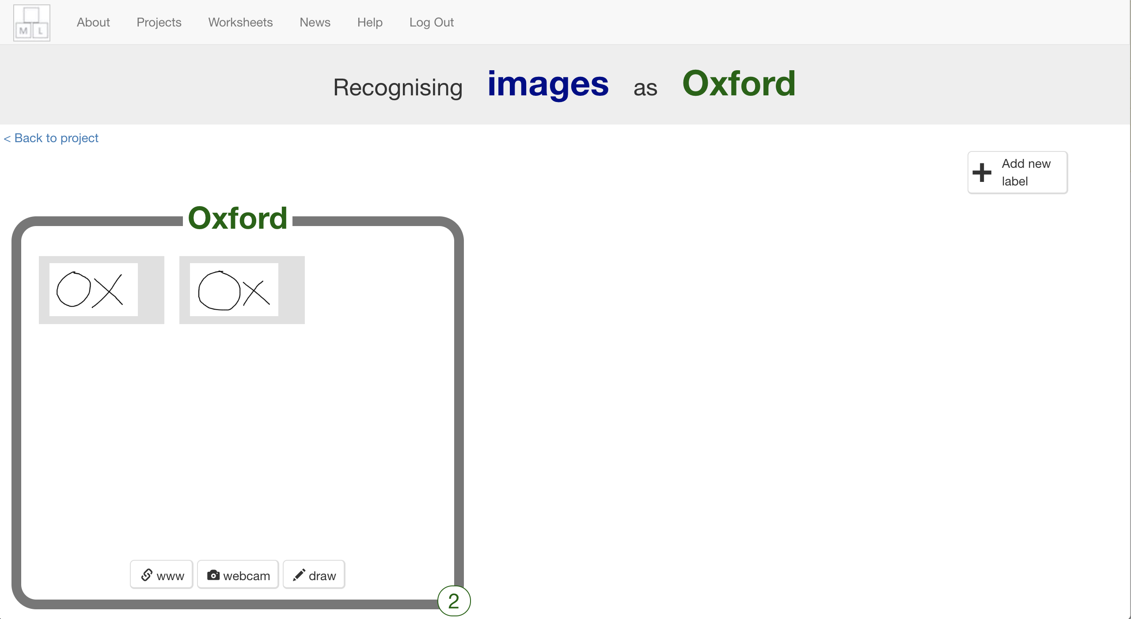

1. 重複上個步驟，直到有10個”OX”範例

Repeat until you’ve got **10** examples of “OX”

1. 點選“**Add new label**”，這次建立一個叫“Guildford”的方框

Click “**Add new label**” again, and create one called “Guildford”  


1. 點選“Guildford”方框的“**Draw**”按鈕，寫出10個“GU”

Use the “**Draw**” button in the “Guildford” bucket to draw 10 “GU” for postcodes in the Guildford area  
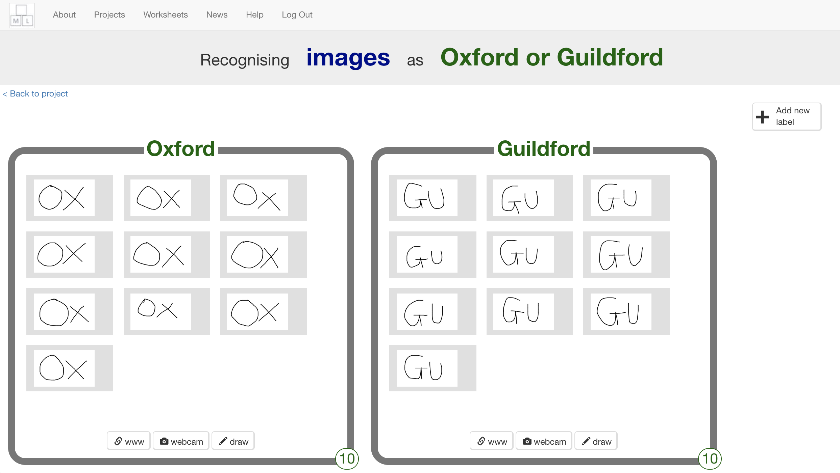

1. 點選“**Add new label**”，建立一個叫“Southampton”的方框

Click “**Add new label**” again, and create one called “Southampton”

1. 在Southampton方框中寫出10個”SO” 區域縮寫範例

Draw 10 “SO” examples for postcodes in the Southampton area  
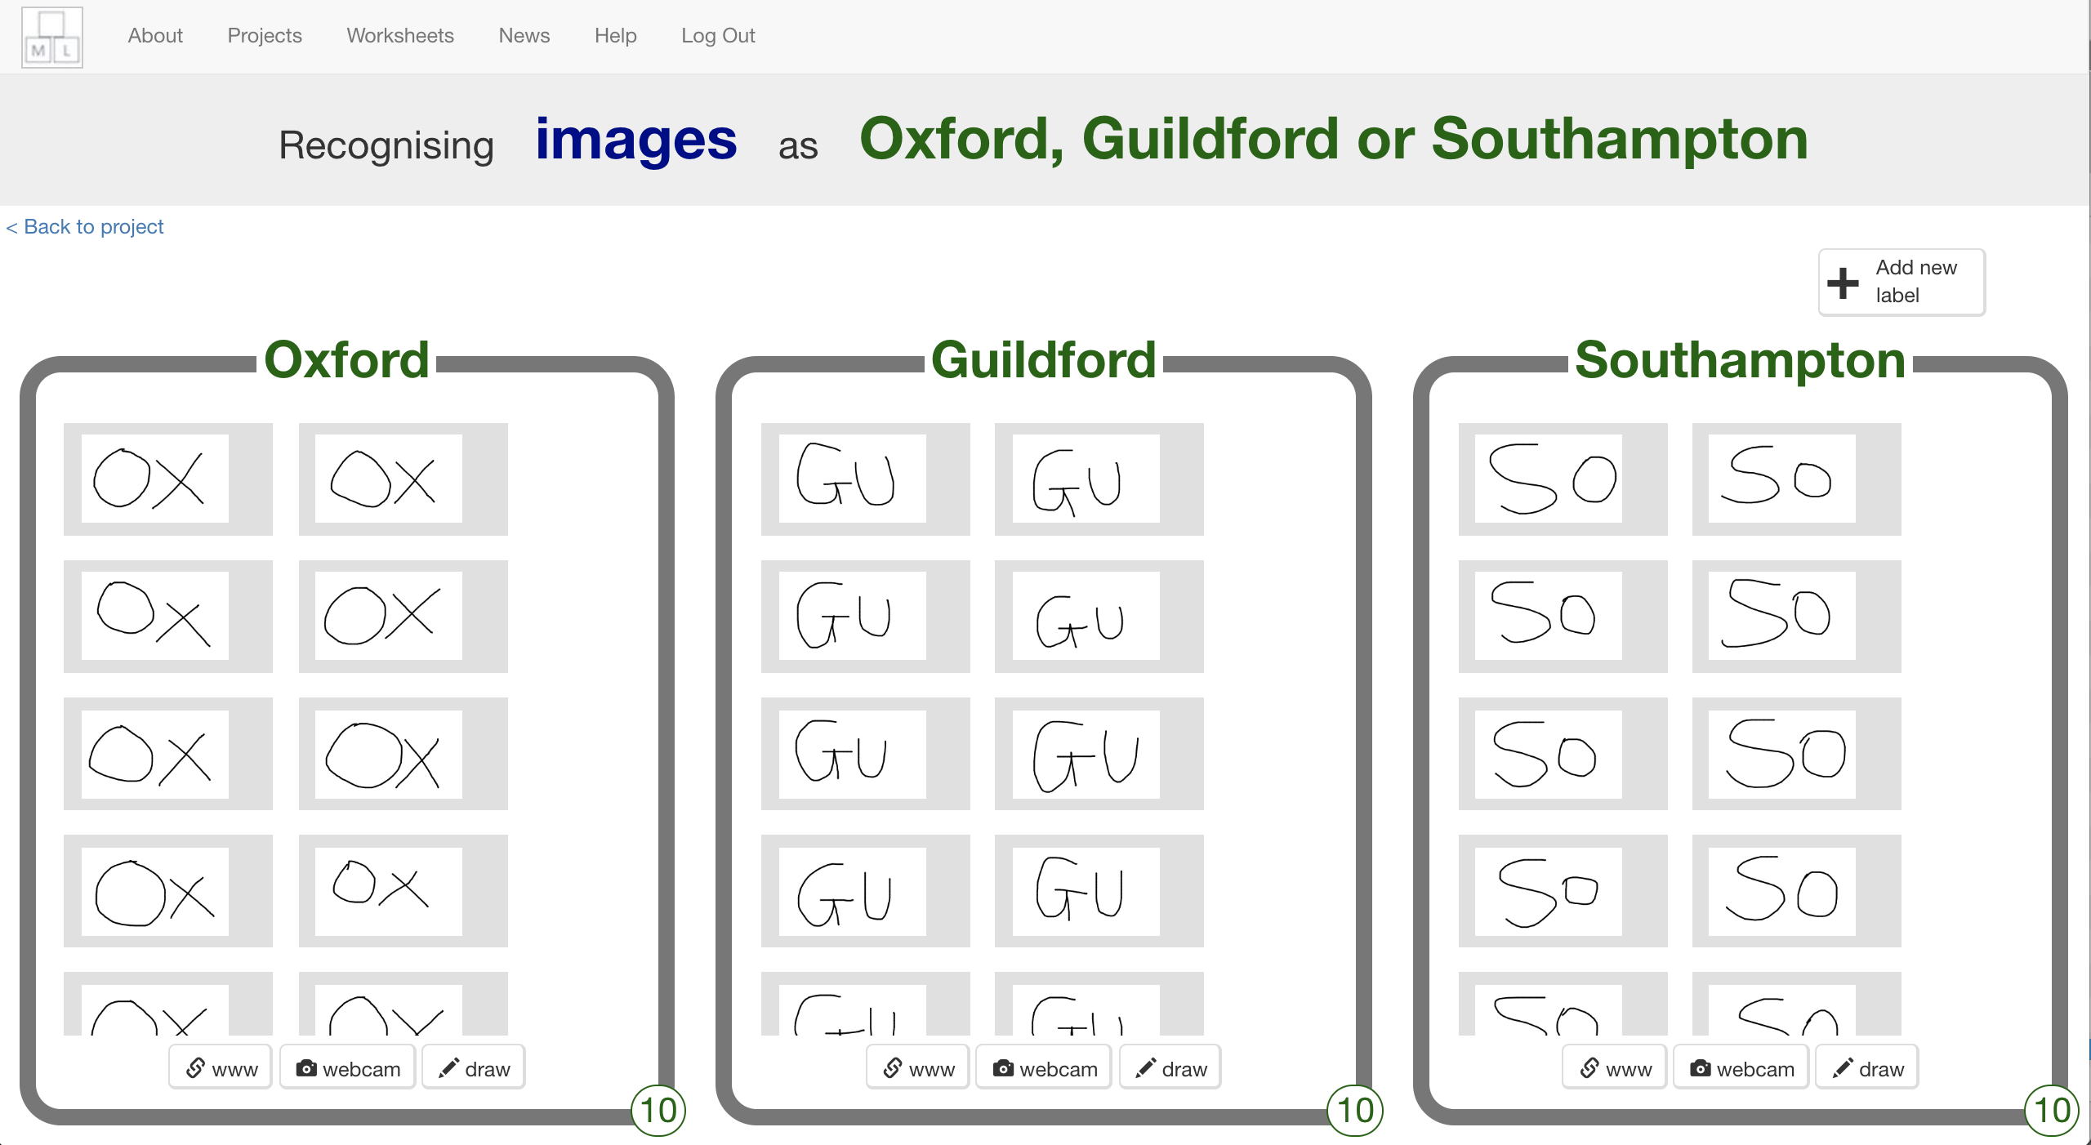

1. 點選“**< Back to project**”

Click on the “**< Back to project**” link

1. 點選 “**Learn & Test**”

Click the “**Learn & Test**” button

1. 點選“**Train new machine learning model**”按鈕

Click the “**Train new machine learning model**” button  
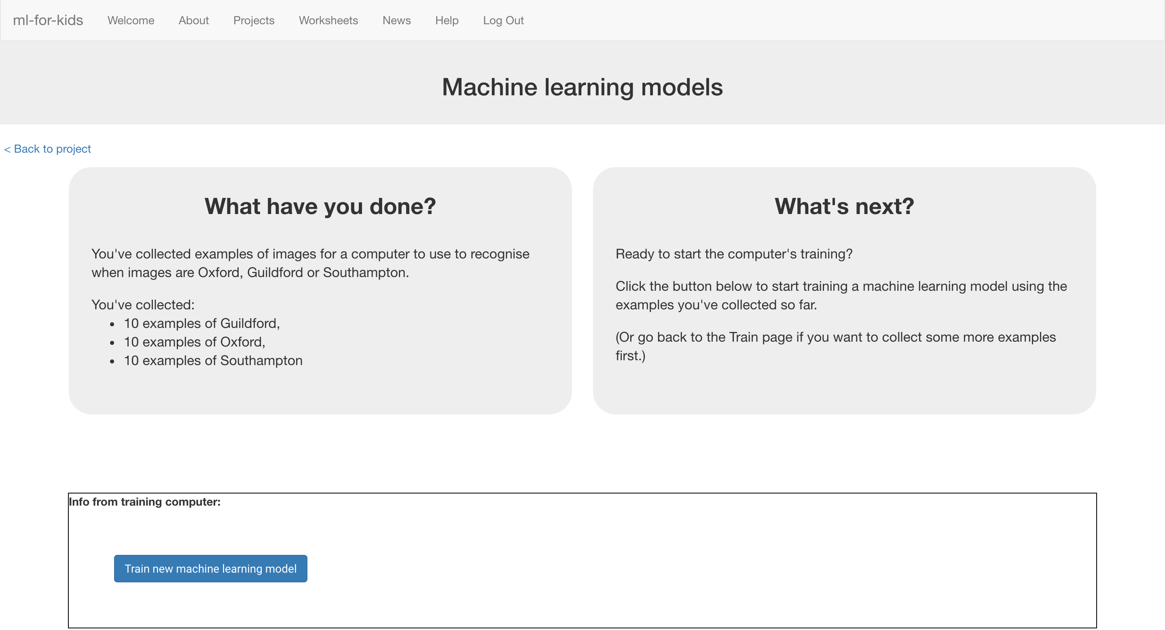

1. 等待訓練完成，這可能需要幾分鐘的時間

Wait for the training to complete. This might take a few minutes.  
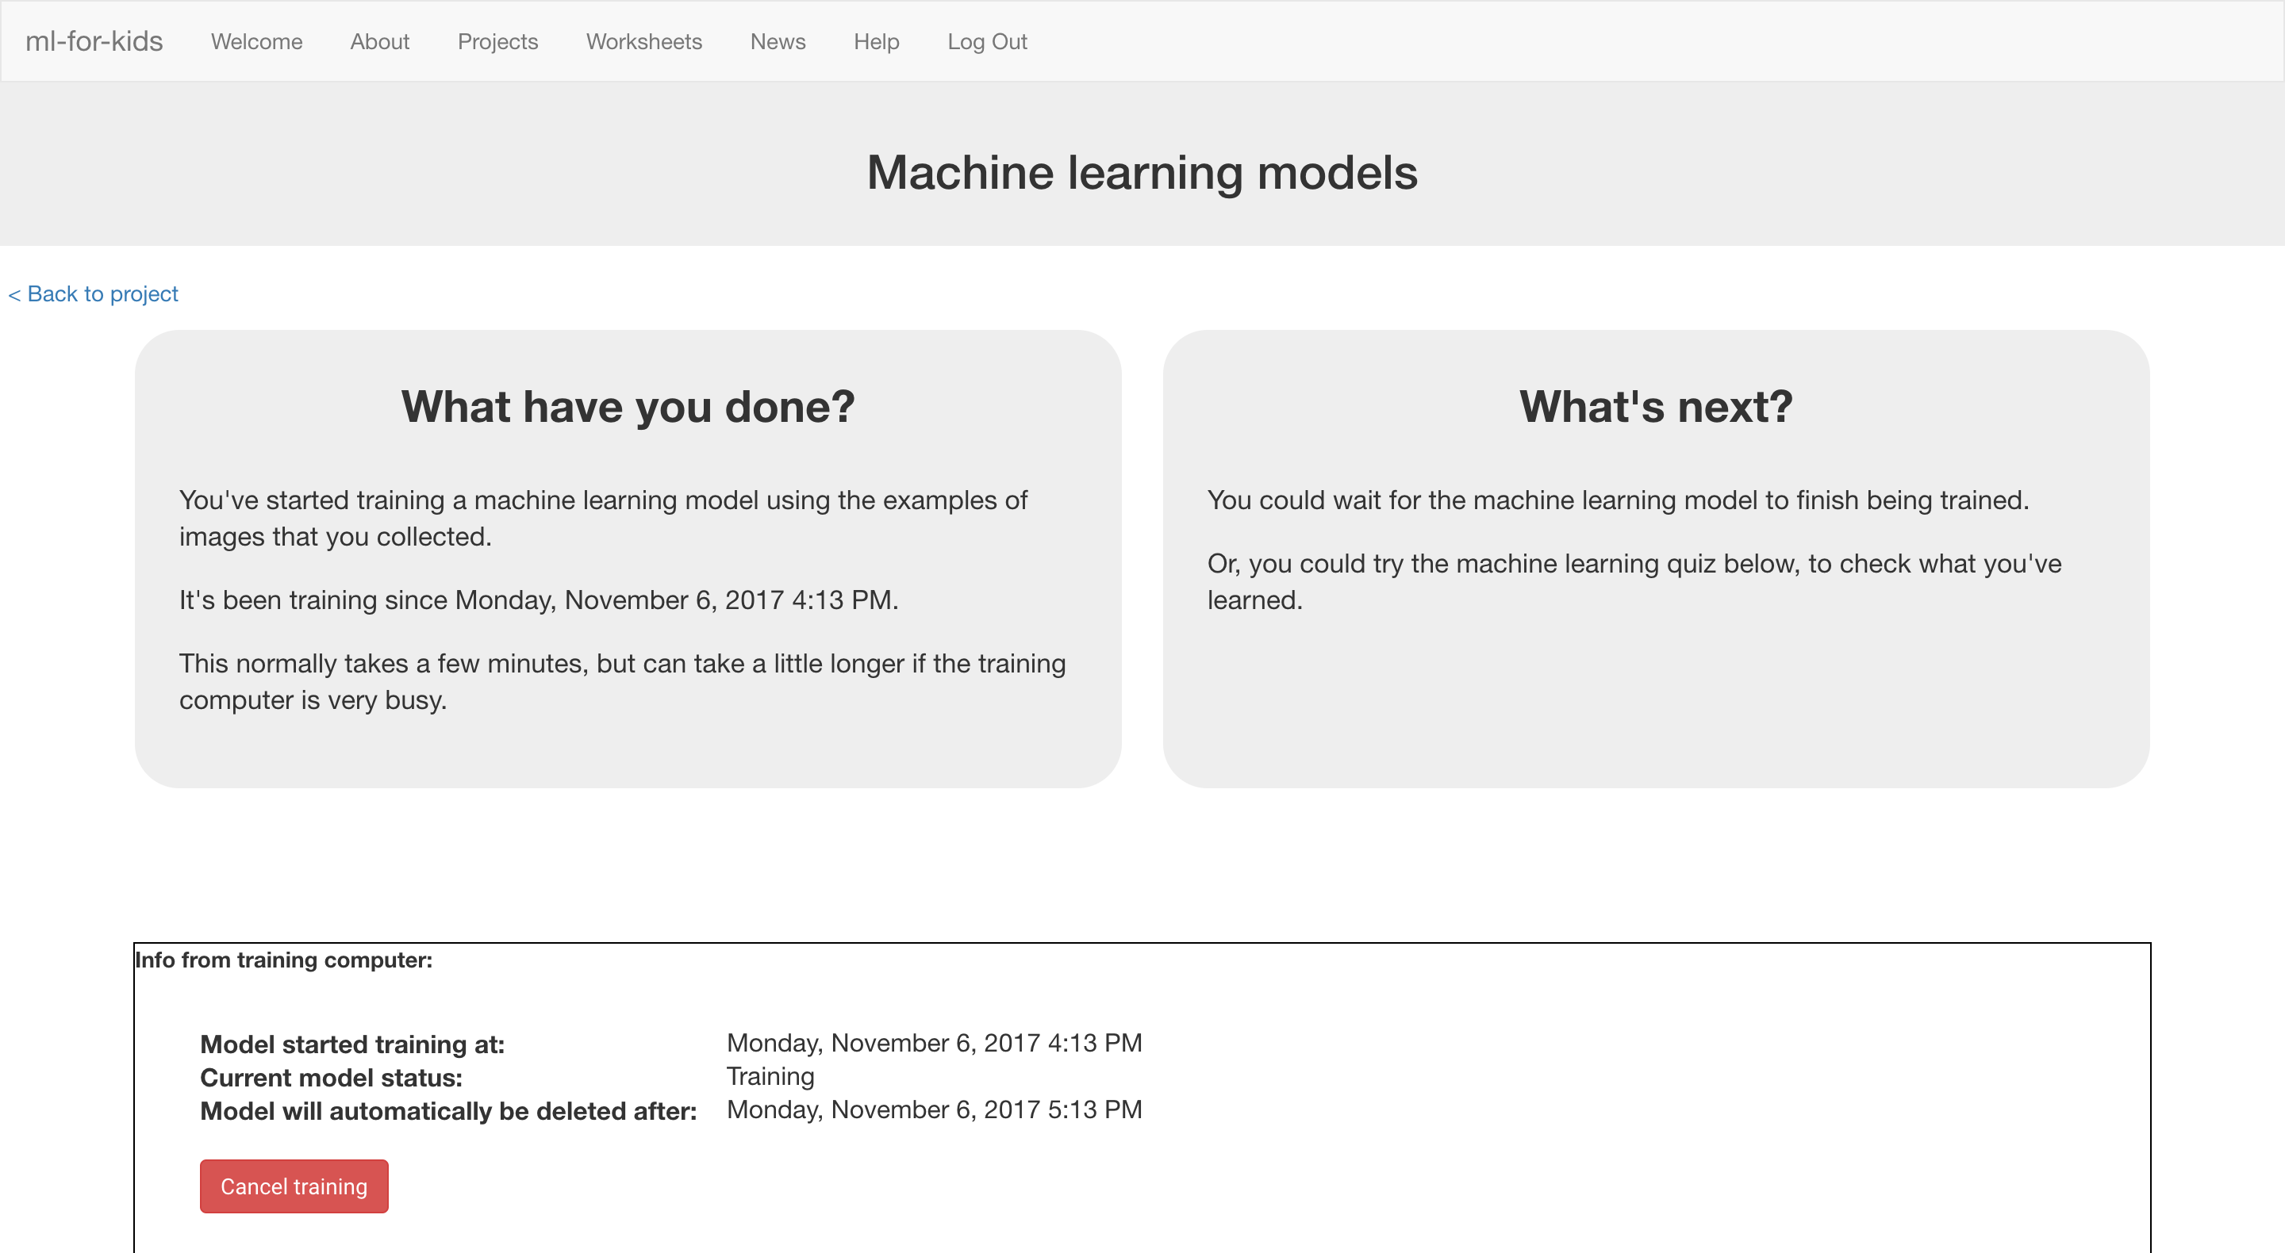

1. 點選“**< Back to project**”

Click the “**< Back to project**” link

1. 點選“**Make**”按鈕

Click the “**Make**” button

1. 點選“**Scratch**

*這個頁面有Scratch新積木的使用教學*

Click the “**Scratch**” button  
*This page has instructions on how to use the new blocks in Scratch*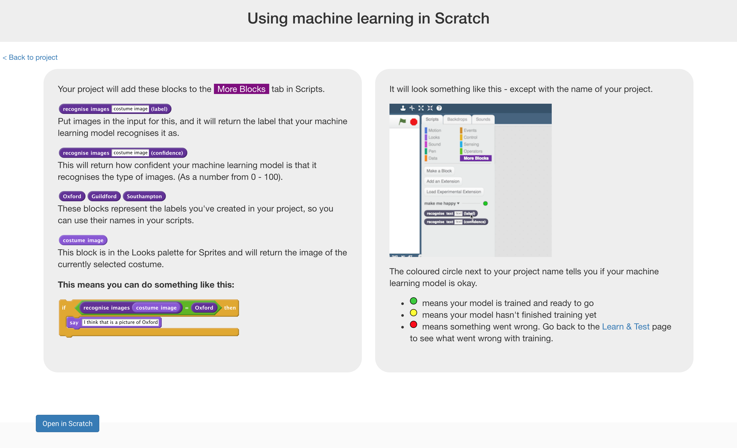

**到目前為止，你做了哪些事情？**

**What have you done so far?**

你蒐集了一些手寫的區域縮寫範例，並開始訓練電腦辨別Oxford、Guildford和Southampton等地區。這些範例會被用來訓練一個機器學習的 『模型』。

You’ve started to train a computer to recognise pictures of handwriting as being the start of postcodes for the Oxford, Guildford, or Southampton area. You are doing it by collecting examples of your handwriting. These examples are being used to train a machine learning “model”.

這是所謂的『監督式學習』，因為你在這個過程中確保（監督）電腦收到的結果是正確的 (supervised learning)。

This is called “supervised learning” because of the way that you are supervising the computer’s training.

電腦會從你給的範例圖片形狀中學到一些模式。這些模式會被用來辨識要被分類的信件上的區域縮寫。

The computer will learn from patterns in the shapes of each of the examples you’ve drawn. This will be used to be able to recognise the postcodes we’ll write on the envelopes to be sorted.

1. 點選**Open in Scratch**

*你會在專案裡的『更多積木』(More blocks)區看到新積木*

Click “**Open in Scratch**” to launch Scratch.   
*You should see new blocks in “More blocks” from “Mailman Max”.*  
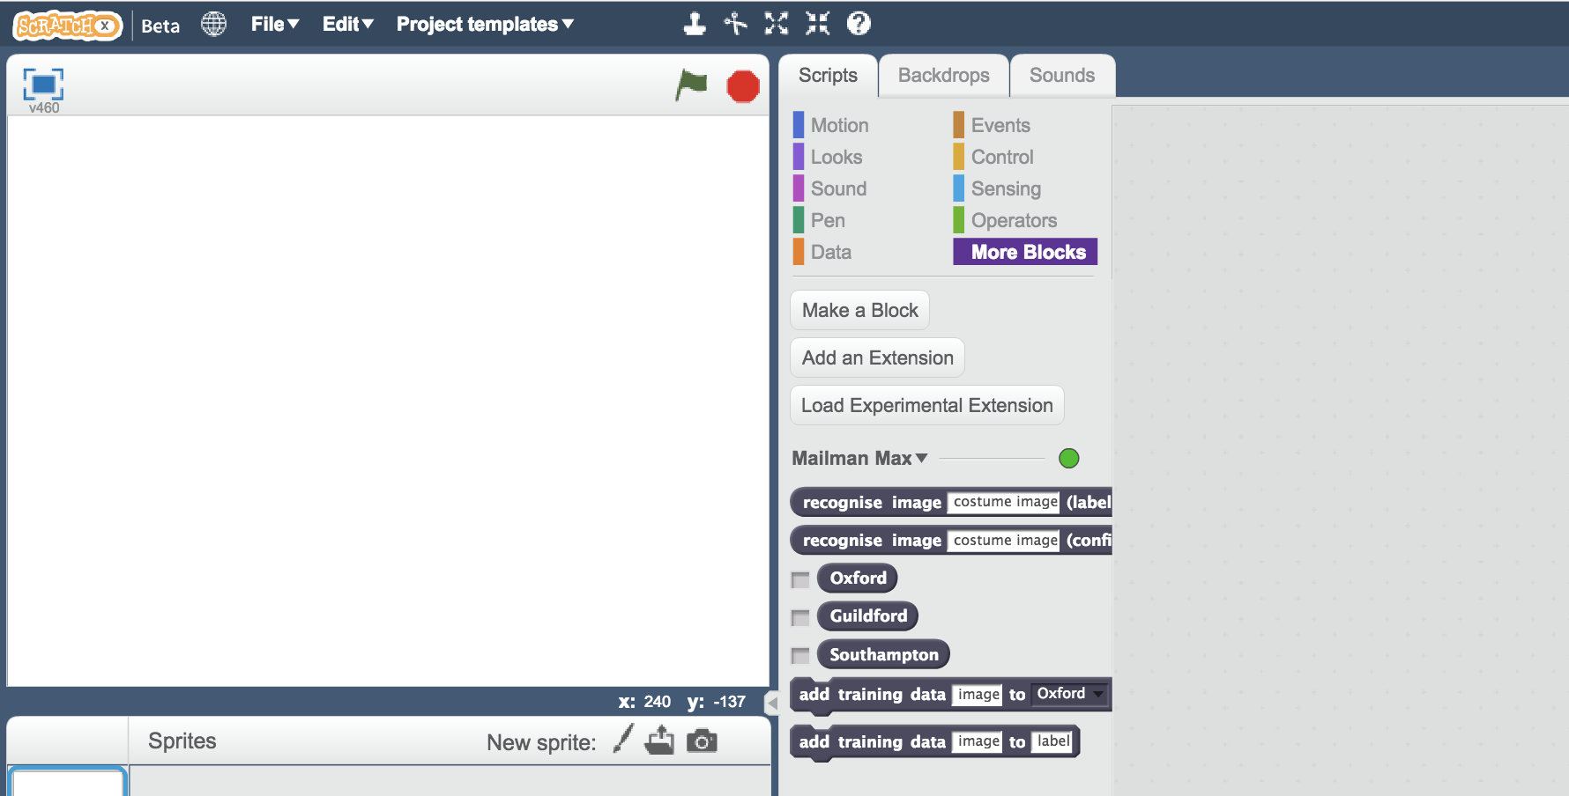

1. 開啟Mailman Max專案

點選***Project templates，***再點選***Mailman Max***

Open the Mailman Max project template   
*Click* ***Project templates*** *->* ***Mailman Max***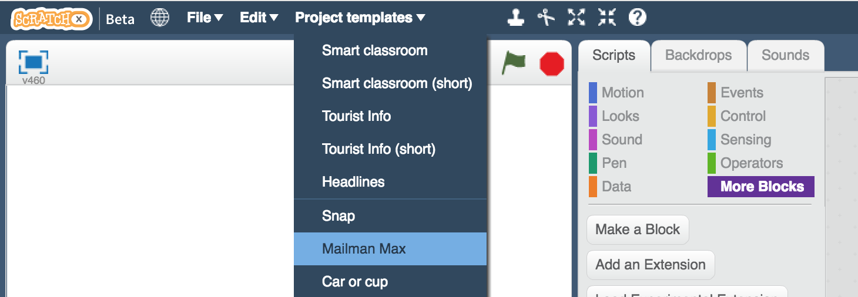

1. 點選角色“**letter**”

Click on the “**letter**” sprite  
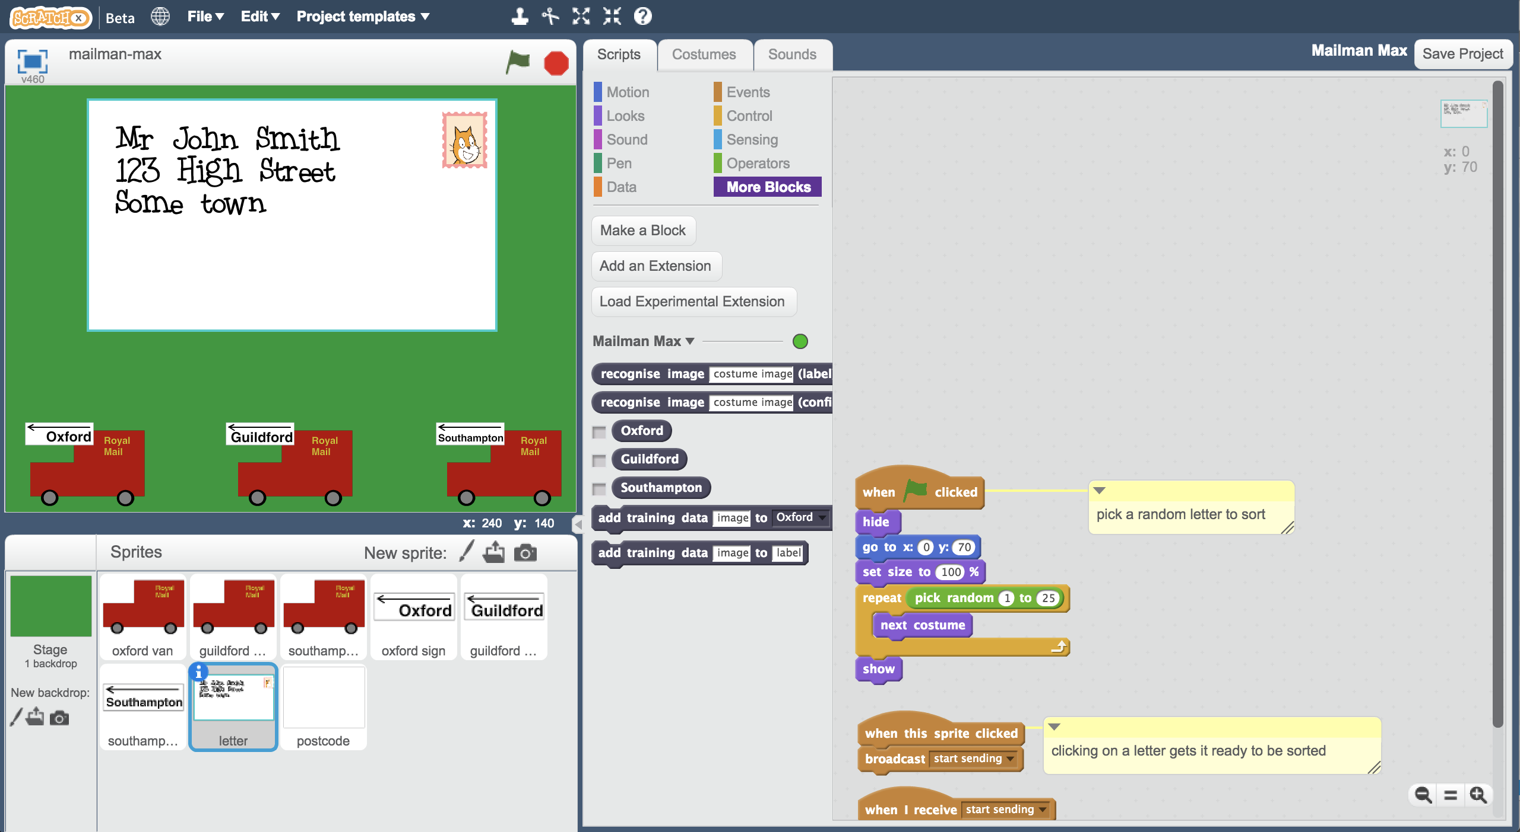

1. 拖曳程式積木（如下圖），這些程式的作用是把分類過的信件放到正確的郵局車上。

Add this so when the letter is sorted, it goes to the correct post van.  
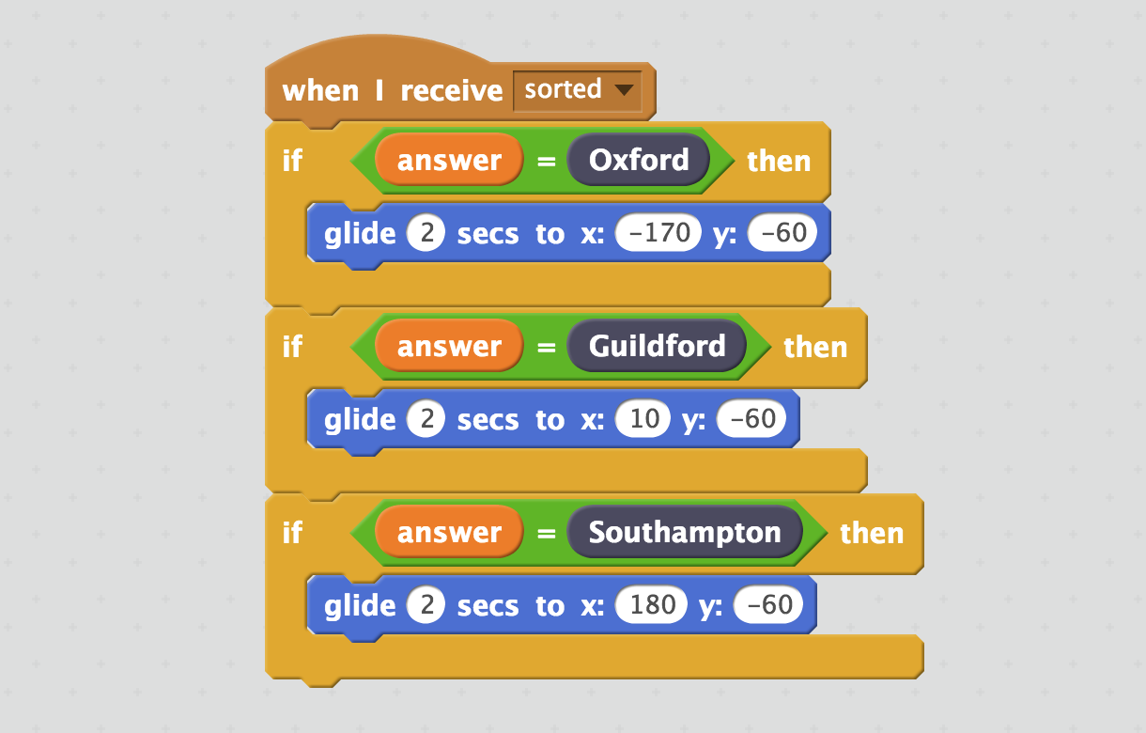

1. 點選角色 “**postcode**”

Click on the “**postcode**” sprite  
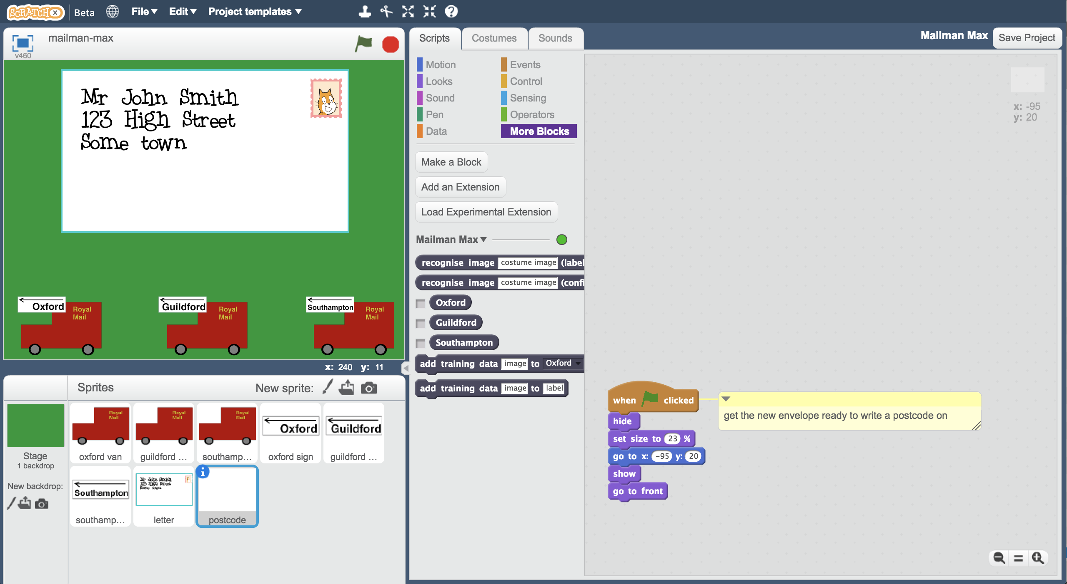

1. 拖曳程式積木（如下圖），這些程式的作用是辨別信封上手寫的區域縮寫

Add this script to get the computer to try to recognise the postcode you write on the envelope.  
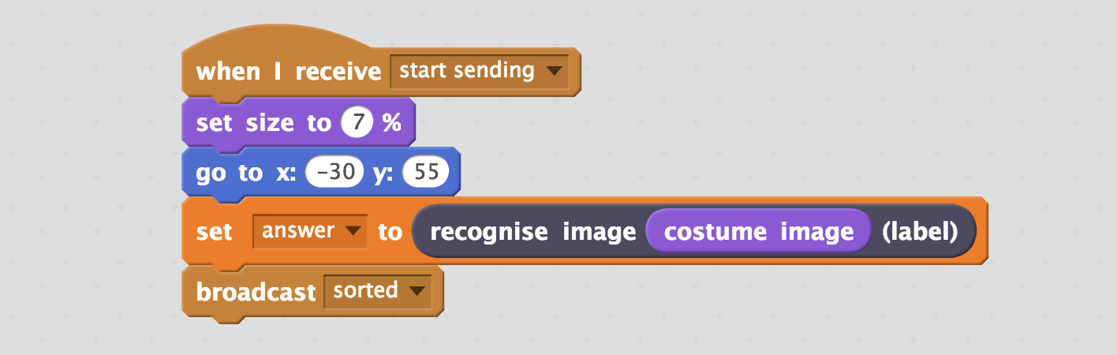

1. 拖曳程式積木（如下圖），這些程式的作用是依照區域縮寫將信件放到正確的郵局車上。

Add the following script to get the handwritten postcode to go to the post van to be taken to the correct regional sorting office.  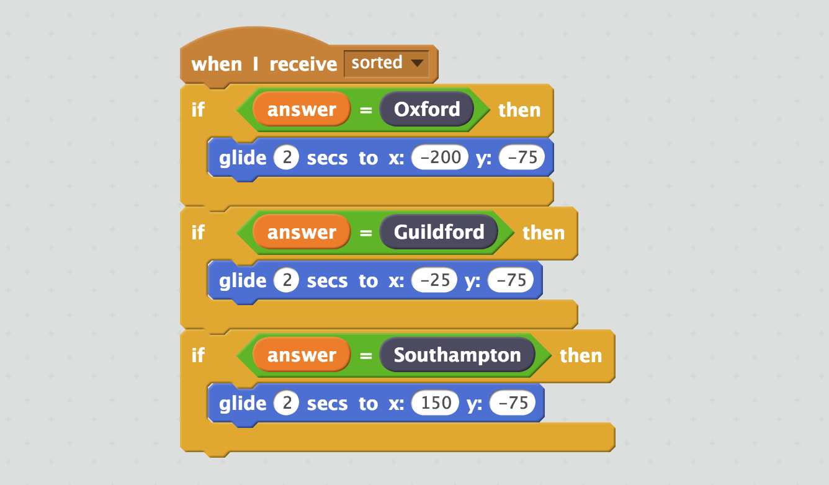

1. 存檔，測試時間到！

*點選檔案，再點選儲存專案*

Save your project  
*Click* ***File*** *->* ***Save Project***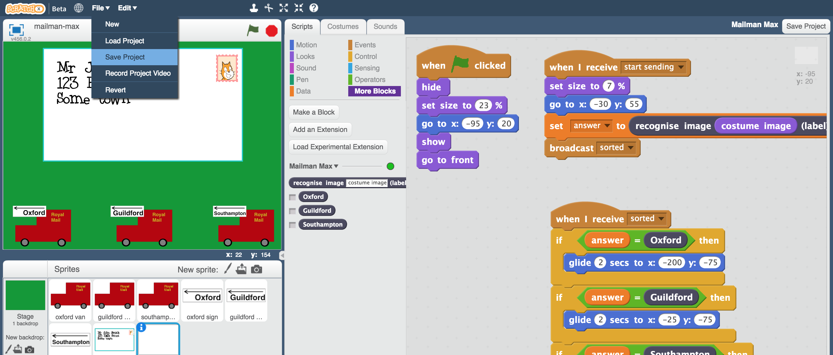

It’s time to test!

1. 點擊綠旗

Click the Green Flag

1. 點選角色“**postcode**”，選擇『造型』

Still on the “**postcode**” sprite, click on “**Costumes**”

1. 調整線條粗細（畫布左下方的拖動條），這樣才能畫出比較粗的線條

Use the line width slider so you can write a thick black line  
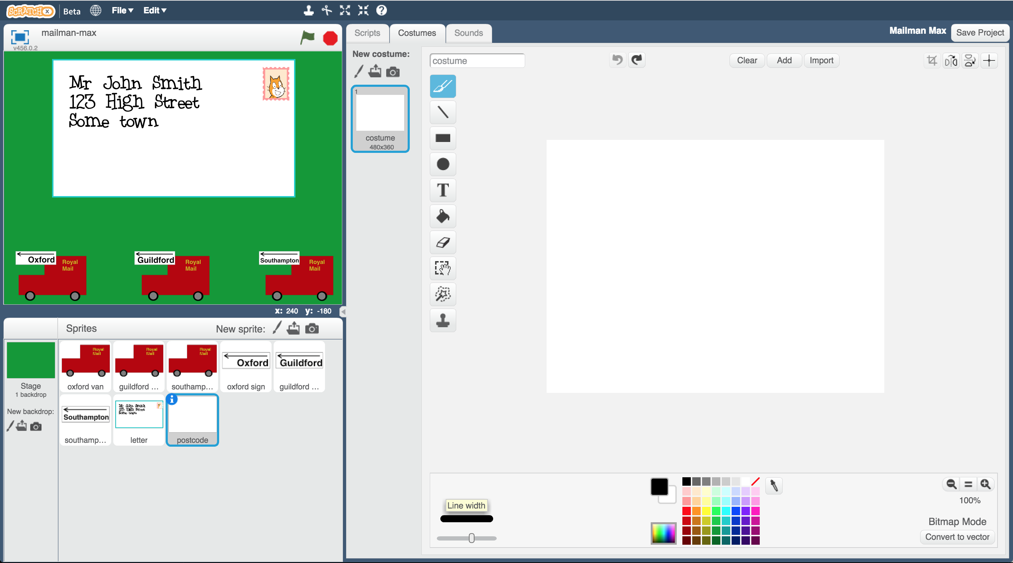

1. 使用畫筆工具寫出地區縮寫的兩個字母

*和訓練時一樣，盡可能寫大一點，填滿畫布空間，你會看到你寫的字母出現在舞台區的信封上*

Write the first two letters of a postcode using the paintbrush tool.  
*Fill the space, like you did with the training examples.  
You should also see it appear in the envelope in the right place.*  
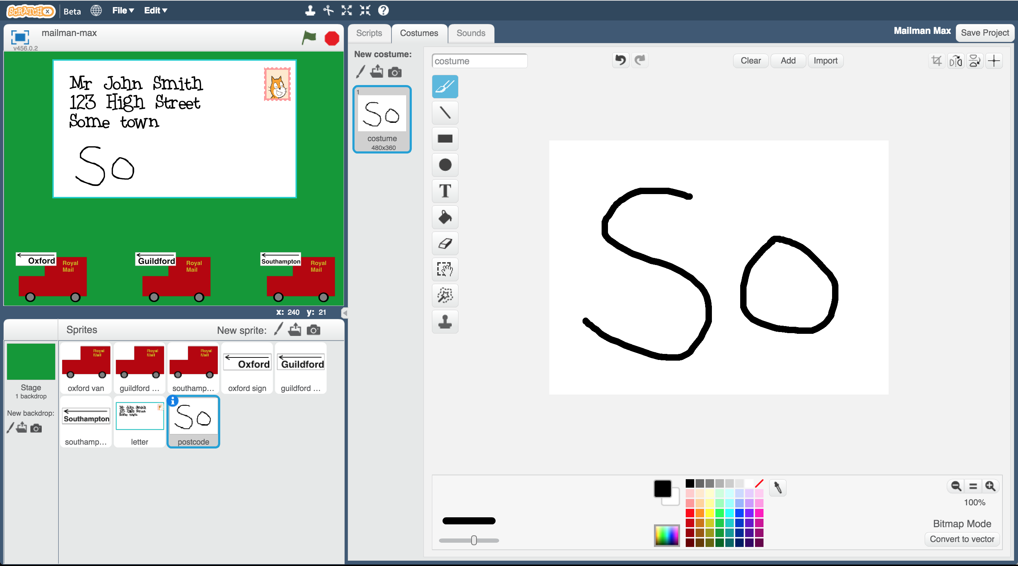

1. 點擊舞台區的郵票圖案

*你會看到信封變小，接著電腦會開始辨別你剛寫區域縮寫。當結果出現時，信封會被移到正確的郵局車上。*

Click on the stamp in the envelope in the stage.  
*You should see the letter shrink. Then the computer will try to recognise the postcode letters you’ve written. Once it thinks it has the answer, the envelope will move to the van for the correct sorting office.*  
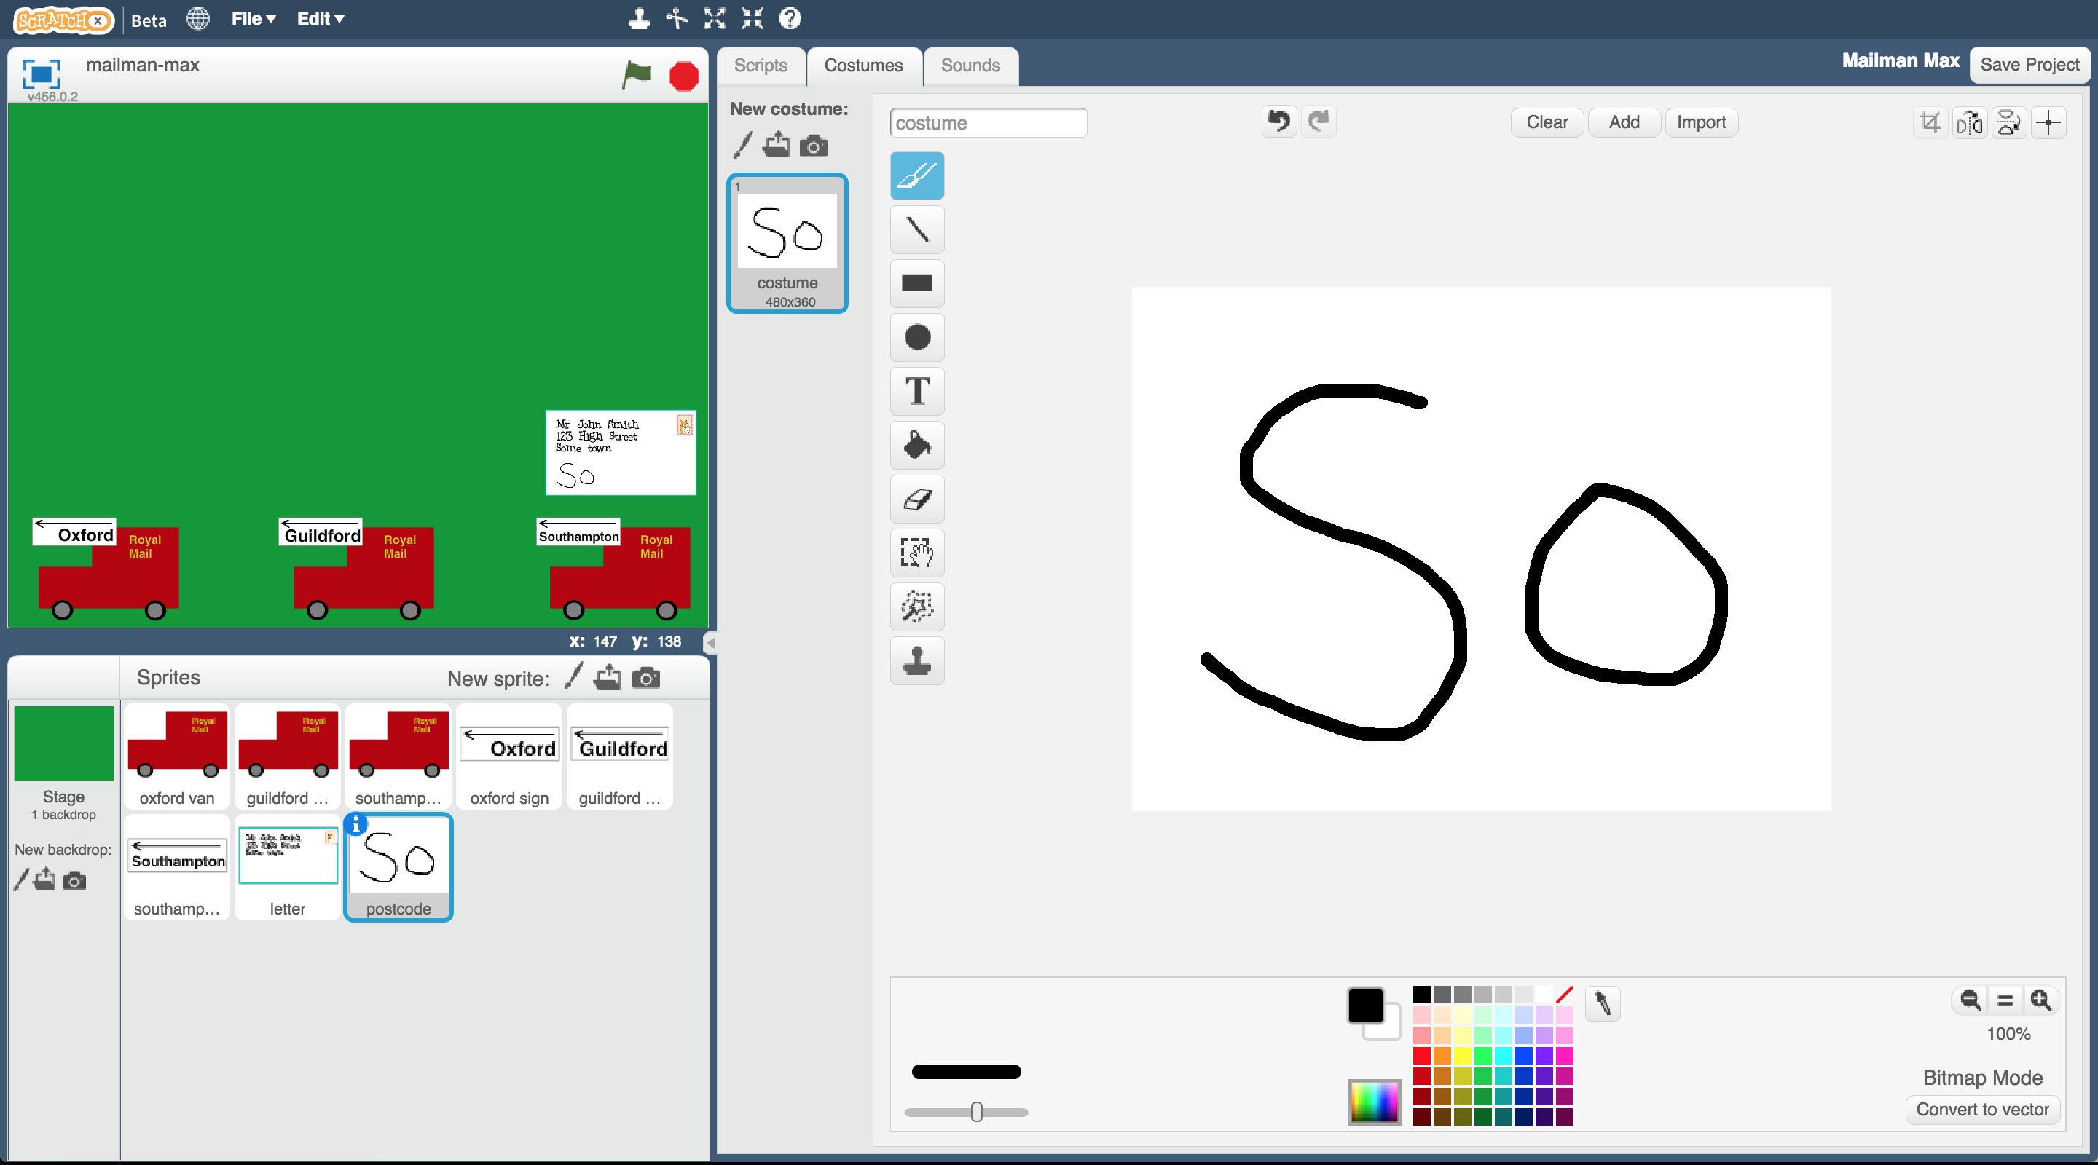

1. 結果正確嗎？

*如果對測試結果不滿意，你可能需要多加一些範例，再使用這些範例建立另一個機器學習模型。*

Did it get it right?  
*If it’s not very good, you might need to add some more examples, and train a new machine learning model with them.*

1. 重複步驟34-38，這次試試不同的區域縮寫

*你會需要先將畫布刷白，消除第一次的測試縮寫。*

***如果你用橡皮擦，記得要重新加入白色背景***

Repeat steps 34-38 to try it again with a different postcode  
*You’ll need to paint over your first postcode in white first.* ***If you use the eraser, make sure you add a white background in again.***  
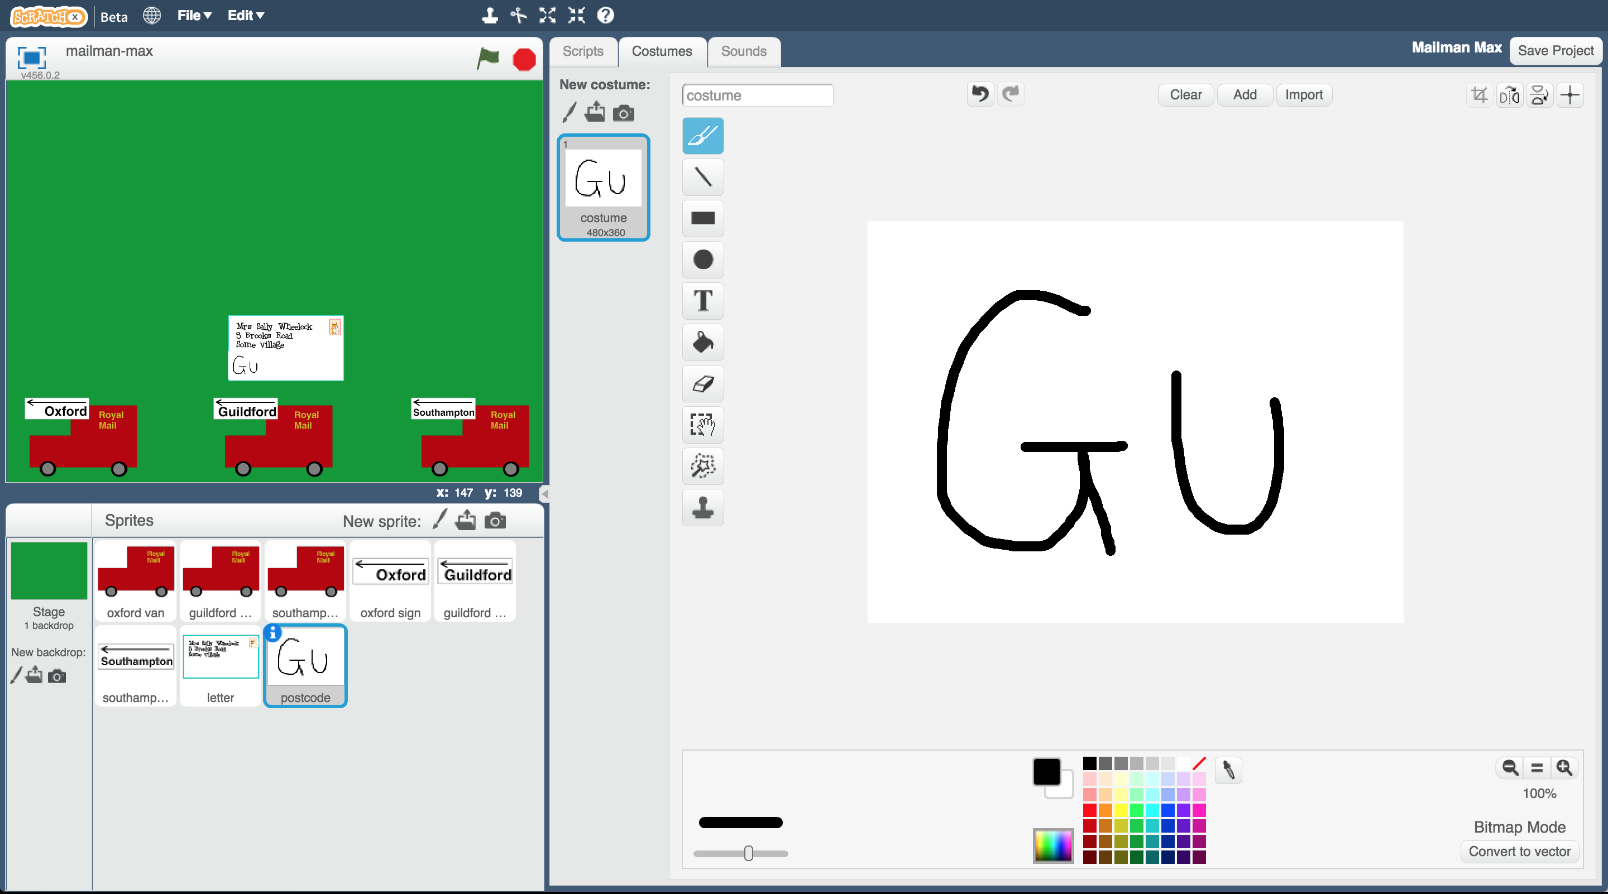

**你完成了什麼？**

**What have you done?**

你訓練了一個機器學習模型來辨別手寫文字。這被稱作光學字元辨識(optical character recognition, OCR)

You’ve trained a machine learning model to be able to do handwriting recognition. This is called “optical character recognition” or “OCR” for short.

你使用蒐集手寫範例的方式來訓練電腦辨別這些文字

You did that by collecting examples of handwriting, to train the computer to be able to recognise it.

你採用了一個小而簡單的作法，只辨識三個區域，而且只使用每個區域的前兩個字母作為區域縮寫

You built a small and simple example, using just the first two letters for just three postcode areas.

想想看，如果要對英國的每個郵遞區域都做這件事，那麼會需要建立120個訓練方框才夠，而且會需要蒐集數千個不同的手寫範例，這樣電腦才能夠得到好的訓練。

Imagine doing the same thing for every postcode area in the country. You’d have to create a lot more training buckets to cover the 120 postcode areas in the UK. And you’d need to collect thousands of training examples, with lots of different people’s handwriting, so that the computer could get really good at recognising them.

這就是現實中郵政系統分類信件的情況。

That is how large postal sorting offices sort our letters in real life.

**延伸活動**

**Ideas and Extensions**

現在你已經完成了這個專案，要不要試試下面的點子？或者，自己想一個？

Now that you’ve finished, why not give one of these ideas a try?

Or come up with one of your own?

**試試別人的手寫文字**

**Try someone else’s handwriting**

你已經訓練電腦辨別你寫的東西，但是電腦能正確地辨識其他人的手寫文字嗎？

You’ve trained the computer to recognise how you write the postcode letters, but would it be able to recognise someone else’s?

請你的朋友幫忙測試看看

Ask a friend to test it and see if it works.

如果電腦運作結果不好，你就需要將你朋友的手寫範例加入訓練資料庫。蒐集到越多人的手寫範例，電腦就可以越正確的辨識不同風格的手寫文字

If it doesn’t, you’ll need to get some examples of their writing to add to your training data. The more people you can get training examples from, the better the computer will be at recognising a variety of handwriting styles.

**將區域縮寫變複雜**

**Try more of the postcode**

我們只使用了區域的前兩個字母當作縮寫來訓練電腦。

We made it easier for the computer by only giving it the first two letters.

但要怎麼讓電腦辨識出“OX1 2JD”也是屬於Oxford區域呢？

But how can we get it to recognise something like “OX1 2JD” as being a postcode in the Oxford area?

如果你可以蒐集到現實生活中的郵件區域縮寫（而不僅是前兩個字母）當作訓練範例的話，你就能訓練電腦來辨別他們，這應該會需要超過10個範例來訓練！

If you collect a variety of different training examples of actual full postcodes (not just the first two letters) you should be able to train it to recognise them. That will probably need more than 10 examples!